

INTERNET OF THINGS- CSE 3009

J-COMPONENT

ADAPTIVE ZONAL IRRIGATION SYSTEM

BY

Vipul Goel (16BCI0115)

ACKNOWLEDGEMENT

The members of the group would like to acknowledge all those who helped with the completion of this project. We would like to thank God for enabling us to finish this project safely and on time. We would like to thank the faculty in charge PROF. Priya G. for helping us choose the topic and monitoring our progress right from the beginning to the end. He has provided us valuable knowledge and advice whenever we hit a dead end. We would also like to thank the college for providing us with this opportunity to do this project by taking up this course and providing us with the state of the art facilities like the Library.

Introduction:

Agriculture is an important part of India’s economy and at present it is among the top two farm producers in the world. This sector provides approximately 52 percent of the total number of jobs available in India. This sector provides approximately 52 percent of the total number of jobs available in India and contributes around 18.1 percent to the GDP. Agriculture is the only means of living for almost two-thirds of the employed class in India. As being stated by the economic data of financial year 2015-2016 agriculture has acquired 18 percent of India’s GDP. The agriculture sector of India has occupied almost 43 percent of India’s geographical area.

Role of Agriculture in Indian Economy:

1. Share in National Income.

2. Largest Employment Providing Sector.

3. Contribution to Capital formation.

4. Providing Raw Material to industries.

5. Market for Industrial Products.

Traditional irrigational practises:

In this method, irrigation is done manually. Here, a farmer pulls out water from wells or canals by himself or using cattle and carries to farming fields. This method can vary in different regions. The main advantage of this method is that it is cheap but efficiency is poor because the even distribution of water is not always possible. Some examples of traditional system are pulley system, lever system, chain pump and dhekli. Among these, the pump system is most common and used widely

Negative side of traditional irrigation practices

1. Due to seepage in drains, wastage of water is caused.
2. Machines cannot be used in check basin method because during spray of insecticides or fertilizers, the earthen walls of basin are damaged.
3. Traditional methods are unsuitable for some types of crops.
4. In furrow irrigation method, due to filling of excess water, there is risk of underground salts coming up to the surface layer.
5. Some traditional methods are not suitable for all soil compositions.
6. One of the disadvantage of this method is that one cannot track the soil fertility (humus, moisture, water depth).

Current solution to this problem of traditional method

In present times, when water crisis is developing very fast everywhere, we should adopt improved techniques of irrigation to encourage suitable water management.

1. Sprinkler method of irrigation:

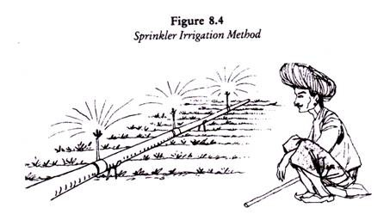

In sprinkler irrigation method, water is taken from source to the fields through pipes, whereas in surface irrigation methods only 30-45 per cent water reaches the crops. Such loss of water is avoided in sprinkler irrigation method. The problem of water logging or ‘kallar’ may be caused in case of excess water from surface irrigation, whereas no such problem is caused in sprinkler irrigation method. The balance of groundwater is also maintained

1. Dip method

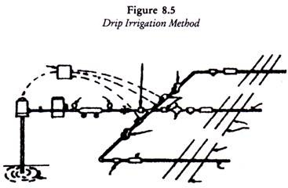

In this irrigation system, a small amount of water is applied at frequent intervals in the form of water droplets through perforations in plastic pipes or through nozzles attached to tubes spread over the soil to irrigate a limited area around the plant.

A precise amount of water equal to the daily consumptive use or the depleted soil water needs to be applied. The soil water can be maintained at the field capacity during the crop growing period. Deep percolation losses can be completely prevented and the evaporation loss is also reduced.

Our proposed method of irrigation.

In our project adaptive zonal irrigation system, we will be supplying water to the crops in the 5 zones based on their moisture levels. A farmer can control the working of the pump using a RF module which consist of a transmitter and a receiver. When the soil probe gets the readings from the soil moisture sensor. The value is transmitted to the receiver through the RF transmitter. The farmer can set the threshold value for each zone and the arduino code sets on the pump whenever the value of the moisture content is less than the required.

CONCEPTUAL DIAGRAM

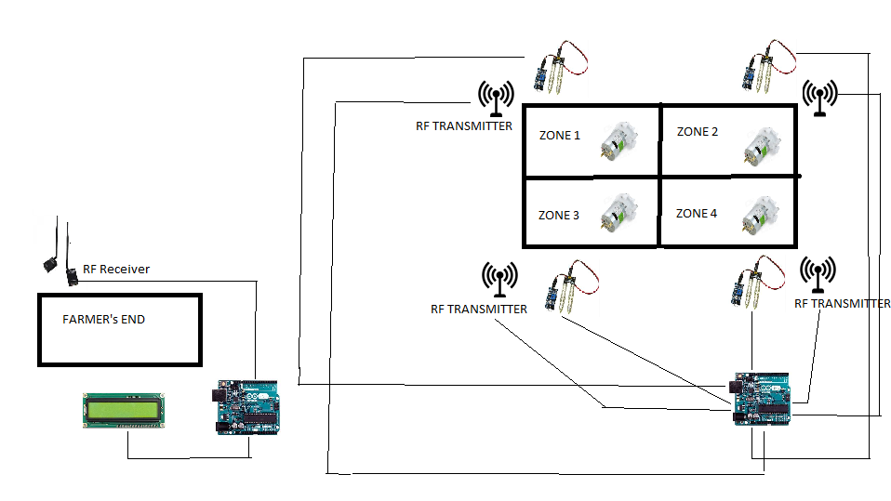

Type of Component s used in our project

* Input (Humidity)
* Output (LCD Display)
* Sensor(Soil Moisture sensor)
* Actuator(5-6V Pump)
* ProgrammableDevice(Arduino)
* Communication(Rf Module)

CONCRETE DIAGRAM

a.Transmitter Circuit Diagram

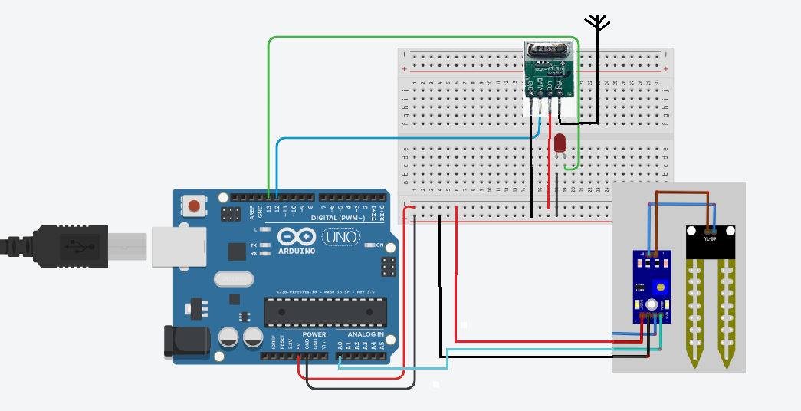

b.Receiver Circuit Diagram

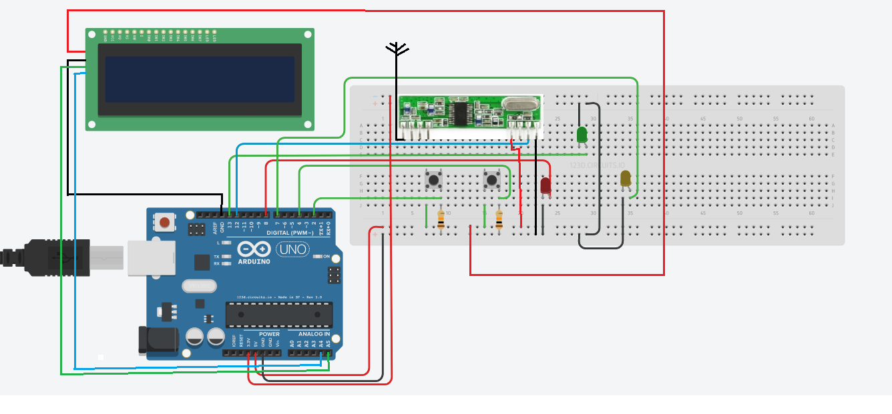

1)INPUT

In our project we are taking the amount of Moisture Le vel in soil.When the Moisture Level is be low a certain level the Pump is triggered else Pump is switched OFF.

2) OUTPUT

To display the amount of Moisture in the soil by using LCD1602 with I2C Arduino Adaptor

a.LCD1602 display

FEATURES

-Display Mode: STN, B LUB

-Display Formate: 16 Character x 2 Line -Viewing Direction: 6 O’Clock

-Input Data: 4 -Bits or 8-Bits interface available -Display Font : 5 x 8 Do ts

-Power Supply : Single Power Supply (5V±10%) -Driving Scheme : 1/16 Duty,1/5Bias

b.I2C Arduino Adaptor

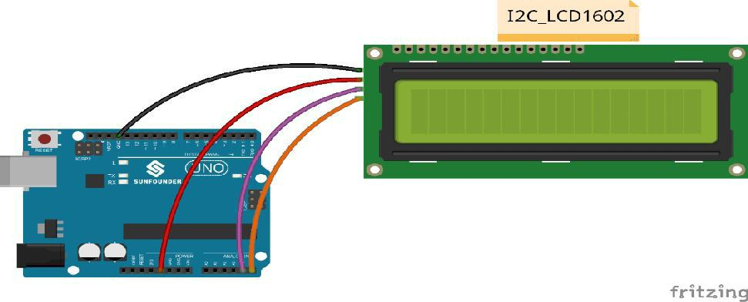I2C bus is a type of serial bus invented by PHLIPS. It is a high performance serial bus which has bus ruling and high or low speed device synchronization function required by multiple-host system. The blue potentiometer on the I2C LCD1602 (see the figure below) is used to adjust the backlight for better display. I²C uses only two bidirectional open-drain lines, Serial Data Line (SDA) and Serial Clock Line (SCL), pulled up with resistor

3) Sensor(Soil Moisture Sensor)

Soil moisture sensors measure the volumetric water content in soil. Since the direct gravimetric measurement of free soil

moisture requires removing, drying, and weighting of a sample, soil moisture sensors measure the volumetric water content indirectly by using some other property of the soil, such as electrical resistance, dielectric constant, or interaction with neutrons, as a proxy for the moisture content. The relation between

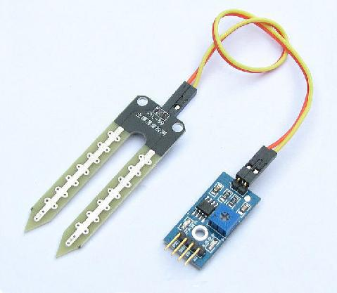

the measured property and soil moisture must be calibrated and may vary depending on environmental factors such as soil type, temperature, or electric conductivity. Reflected microwave radiation is affected by the soil moisture and is used for remote sensing in hydrology and agriculture. Portable probe instruments can be used by farmers or gardeners.

Soil moisture sensors typically refer to sensors that estimate volumetric water content. Another class of sensors measure another property of moisture in soils called water potential; these sensors are usually referred to as soil water potential sensors and include tensiometers and gypsum blocks.

LM393 Driver:

LM393 device consist of two independent low voltage comparators designed specifically to operate from a single supply over a wide range of

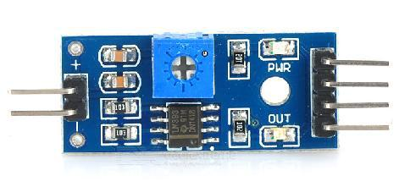voltages.Operation from split power supplies is also possible.These comparators also have a unique characterstic in

that the input common-mode voltage rangeincludes ground even though operated from a single power supply voltage

Working:

Soil moisture sensors measures the water content in soil.A soil moisture probe is made up of multiple soil moisture sensors.One common type of soil moisture sensors commercial use of frequency domain sensors such as a capacitance sensor. Another sensor,the neutron moisture gauge,utilises the moderator properties of water for neutrons.Soil moisture content may be determined via its effect on dielectric constant by measuring the capacitance between two electrodes implanted in the soil. Where soil moisture is predominantly in the form of free water ,the dielectric constant is directly proportional to the moisture content. The probe is normally given a frequency excitation to permit measurement of the dielectric constant. The readout from the probe is not linear with water content and is influenced by soil type and soil temperature. Therefore,careful calibration is required and long term stability of the calibration is questionable.

4) Arduino board.

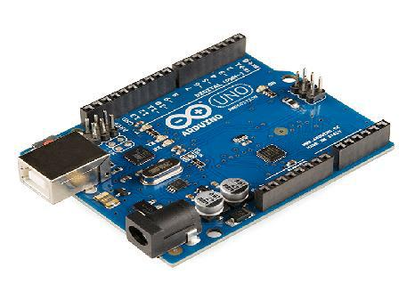Arduino board designs use a variety of microprocessors and controllers. The boards are equipped with sets of digital and analog input/output (I/O) pins that may be interfaced to various expansion boards (*shields*) and other circuits. The boards feature serial communications interfaces, including Universal Serial Bus (USB) on some models,

which are also used for loading programs from personal computers. Themicrocontrollers are typically programmed using a dialect of

features from the programming languages C and C++. In addition to using traditional compiler tool chains, the Arduino project provides an integrated development environment (IDE) based on the Processing language project.



5) Actuator(5-6v Pump)

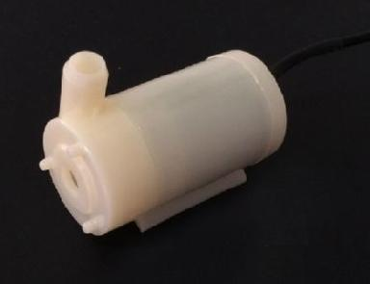An actuator is a component of a machine that is responsible for moving or controlling a mechanism or system.Here we ae using a pump as an actuator to control the movement of water for irrigation An actuator requires a control signal and a source of energy. Here the signal is provided by the moisture sensor. The supplied main energy source may be electric current. When the control signal is received, the actuator responds by converting into desired signal.

6) Communicator(RF Module)

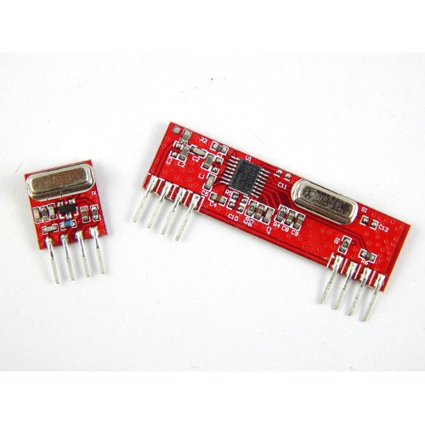An **RF module** (radio frequency module) is a (usually) small electronic device used to transmit and/or receive radio signals between two devices. In an embedded system it is often desirable to communicate with another device wirelessly. This wireless communication may be accomplished through optical communication or through radio frequency (RF) communication. For many applications the medium of choice is RF since it does not require line of sight. RF communications incorporate a transmitter or receiver.

RECEIVER CODE EXPLANATION USING FLOWCHART

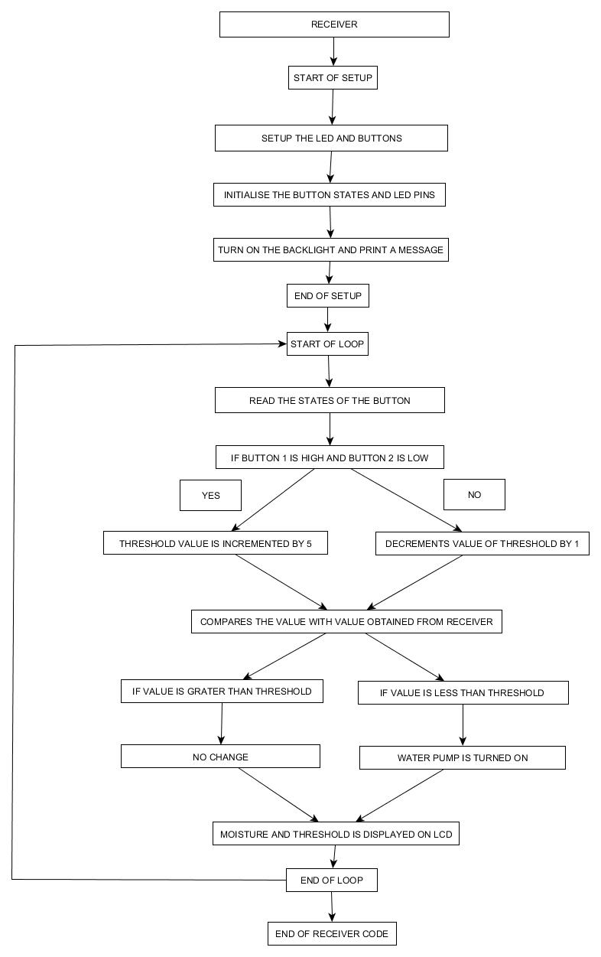

.

TRANSMITTER CODE EXPLANATION USING FLOWCHART

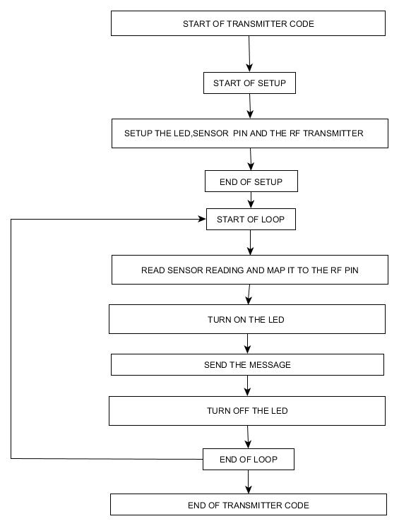

PROJECT SNAPSHOTS

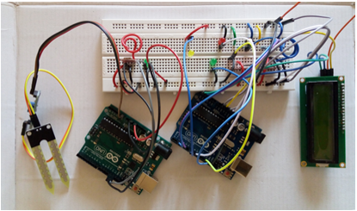

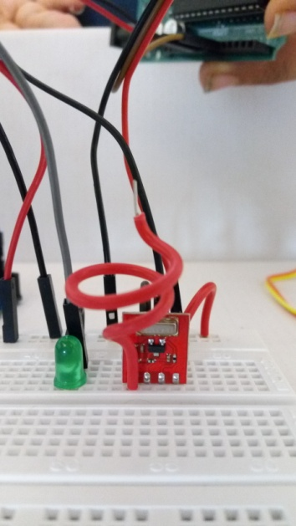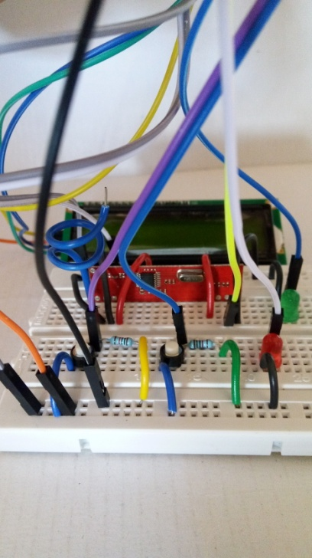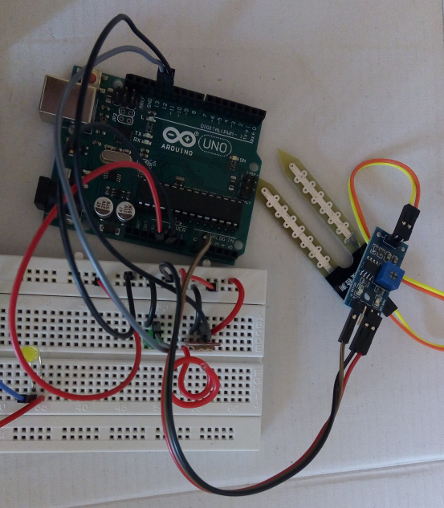

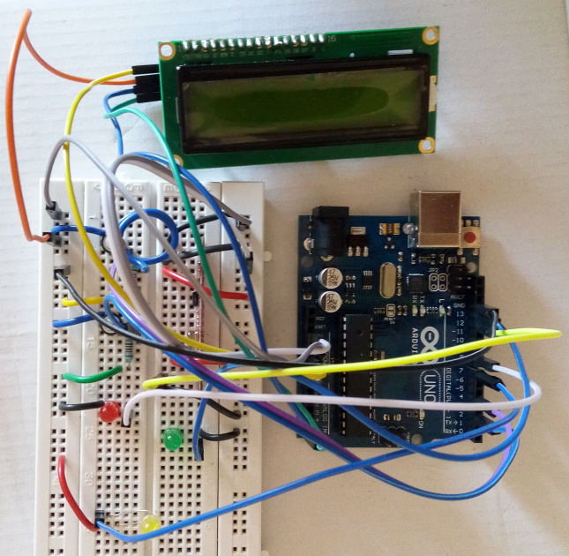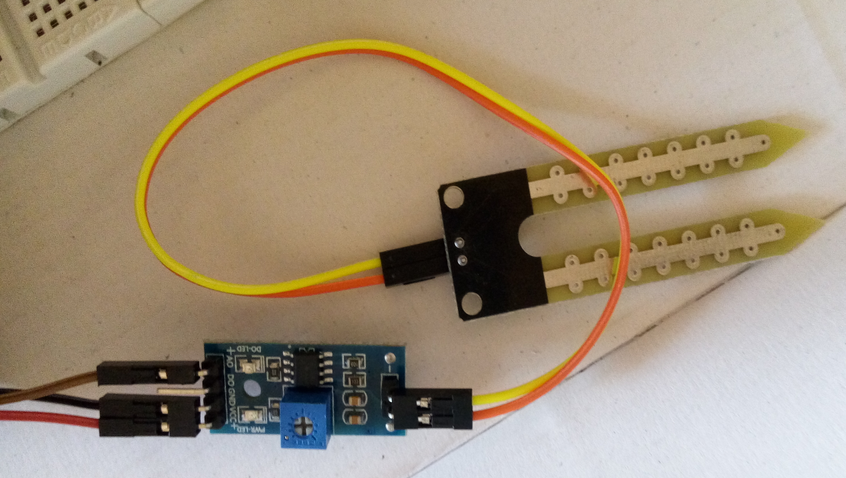

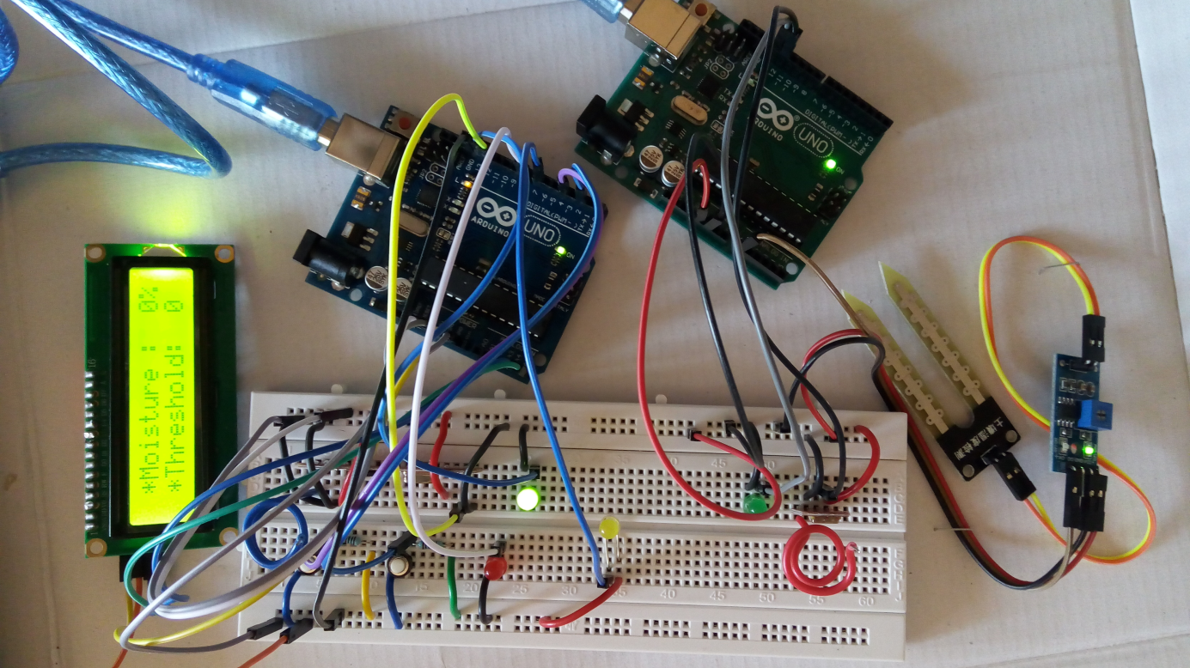

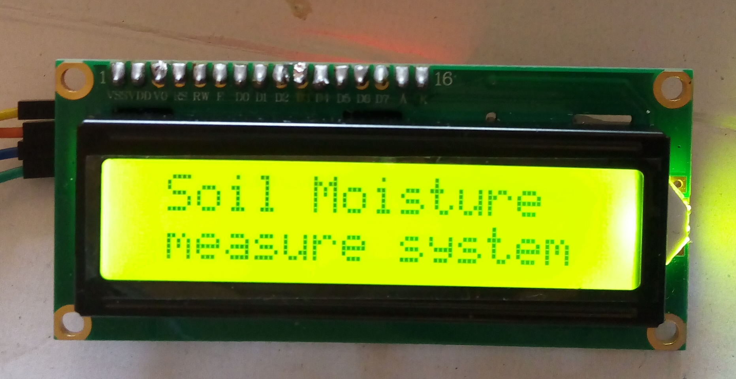

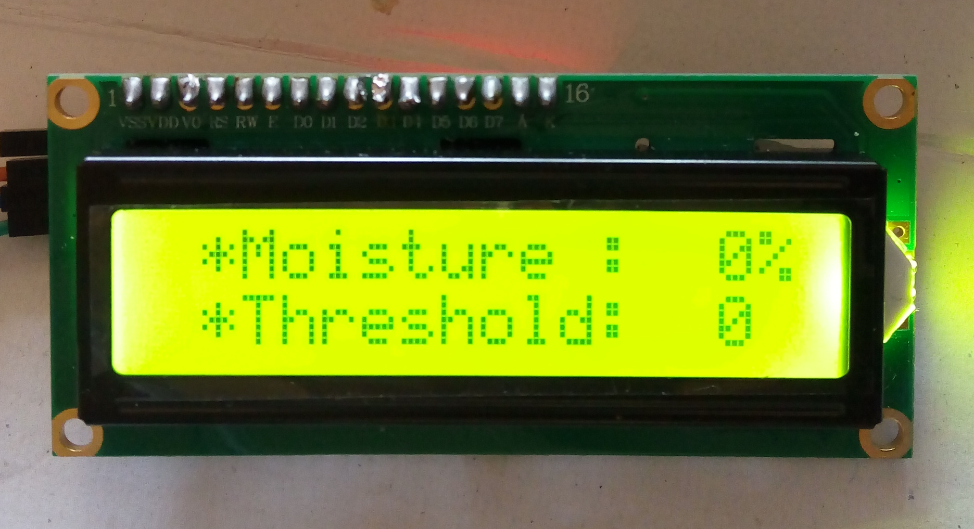

CONCLUSION:

Our project "Adaptive Zonal Irrigation System" is a new strategy that can be followed by farmers to reduce their daily monitoring of moisture in their plots and it also helps in producing a higher yield of crops.This can be more effective mode of irrigation than previous methods of irrigation.This also helps in saving water which is one of the most important water resources and there is a need in protection of this natural resource.This project has succesfully made use of RF sensors and arduino programming. The government can also monitor the amount of water used in the plots of the farmers and charge a fine if they are overusing the natural resource.

There can also be a lot of future work that can be done taking these skills as a base.

REFERENCES

www.electroschematics.com/6519/simple-soil-moisture-sensor-arduino-

www.project/arduinosensors.com/index.php/soil-moisture-sensor-interface-with-arduino-uno/

https://learn.sparkfun.com/tutorials/soil-moisture-sensor-hookup-guide

fritzing.org

APPENDIX

**RECEIVER CODE**

#include <LiquidCrystal_I2C.h>

#include <VirtualWire.h>

// Set the LCD address to 0x27 for a 16 chars and 2 line display

LiquidCrystal_I2C lcd(0x3f, 2, 1, 0, 4, 5, 6, 7, 3, POSITIVE);

const int buttonPin1=2;

const int buttonPin2=4;

const int ledPin1=8;

int threshold=0;

int buttonState1=0;

int lastbuttonState1=0;

int buttonState2=0;

int lastbuttonState2=0;

// LED's

int ledPin = 13;

int ledPin2 = 7;

const int datain = 12;

// Sensors

int Sensor1Data;

// RF Transmission container

char Sensor1CharMsg[4];

void setup() {

// sets the digital pin as output

pinMode(ledPin, OUTPUT);

pinMode(ledPin1,OUTPUT);

pinMode(ledPin2,OUTPUT);

pinMode(buttonPin1,INPUT);

pinMode(buttonPin2,INPUT);

// initialize the LCD

lcd.begin(16,2);

// Turn on the blacklight and print a message.

lcd.backlight();

lcd.setCursor(1, 0);

lcd.print("Soil Moisture");

lcd.setCursor(1, 1);

lcd.print("measure system");

delay(3000);

lcd.clear();

// VirtualWire

// Initialise the IO and ISR

// Required for DR3100

vw_set_ptt_inverted(true);

vw_set_rx_pin(datain);

// Bits per sec

vw_setup(2000);

// Start the receiver PLL running

vw_rx_start();

} // END void setup

void loop(){

buttonState1 = digitalRead(buttonPin1);

buttonState2 = digitalRead(buttonPin2);

//if(buttonState2==HIGH){

if(buttonState1!=lastbuttonState1){

if(buttonState1==HIGH){

threshold+=5;

digitalWrite(ledPin1,HIGH);

}

else{

digitalWrite(ledPin1,LOW);

}

lastbuttonState1=buttonState1;

}

if(buttonState2!=lastbuttonState2){

if(buttonState2==HIGH){

threshold-=1;

digitalWrite(ledPin1,HIGH);

}

else{

digitalWrite(ledPin1,LOW);

}

lastbuttonState2=buttonState2;

}

lcd.setCursor(1,1);

lcd.print("*Threshold: ");

if(threshold<10 and threshold>=0) lcd.print(" ");

lcd.print(threshold);

//}

uint8_t buf[VW_MAX_MESSAGE_LEN];

uint8_t buflen = VW_MAX_MESSAGE_LEN;

// Non-blocking

if (vw_get_message(buf, &buflen))

{

int i;

// Turn on a light to show received good message

digitalWrite(13, true);

// Message with a good checksum received, dump it.

for (i = 0; i < buflen; i++)

{

// Fill Sensor1CharMsg Char array with corresponding

// chars from buffer.

Sensor1CharMsg[i] = char(buf[i]);

}

// Null terminate the char array

// This needs to be done otherwise problems will occur

// when the incoming messages has less digits than the

// one before.

Sensor1CharMsg[buflen] = '\0';

// Convert Sensor1CharMsg Char array to integer

Sensor1Data = atoi(Sensor1CharMsg);

lcd.setCursor(1, 0);

lcd.print("*Moisture :");

if (Sensor1Data < 10) lcd.print(" ");

else lcd.print(" ");

lcd.print(Sensor1Data);

lcd.print("%");

//delay(3000);

if(Sensor1Data<threshold){

digitalWrite(7,true);

}

else{

digitalWrite(7,false);

}

digitalWrite(13, false);

}

// Turn off light to and await next message

//digitalWrite(13,true);

}

**TRANSMITTER CODE**

#include <VirtualWire.h>

// LED's

const int ledPin = 13;

// Sensors

const int Sensor1Pin = A0;

int Sensor1Data;

int Sensor2Data;

char Sensor1CharMsg[4];

void setup() {

// PinModes

// LED

pinMode(ledPin,OUTPUT);

// Sensor(s)

pinMode(Sensor1Pin,INPUT);

vw_set_ptt_inverted(true);

vw_set_tx_pin(12);

// VirtualWire setup

vw_setup(2000); // Bits per sec

}

void loop() {

// Read and store Sensor 1 data

Sensor1Data = analogRead(Sensor1Pin);

Sensor2Data = map(Sensor1Data, 1023,0,0,100);

// Convert integer data to Char array directly

itoa(Sensor2Data,Sensor1CharMsg,10);

digitalWrite(13, true); // Turn on a light to show transmitting

vw_send((uint8_t *)Sensor1CharMsg, strlen(Sensor1CharMsg));

vw_wait_tx(); // Wait until the whole message is gone

digitalWrite(13, false); // Turn off a light after transmission

delay(200);

} // END void loop...